**CS551 Advanced Software Engineering**

**LAB ASSIGNMENT #6**

**Lab Submission before 2016/10/05 (Wed) 11:59PM**

* Submit the screenshots of the task in wiki page and post the link for it in README.md file in Github and push the code to Source folder in Github.

* Submit your Lab report through [**https://goo.gl/forms/YP0GW9Oq2M5GxyMG2**](https://goo.gl/forms/YP0GW9Oq2M5GxyMG2)

Create a signup page with Basic details like First name, Last name, Image, Address etc.

Image should be populated by using Camera or Gallery.

Address should be populated using Location Manager.

After Signup, show an Activity named “Home” which has a Map with Custom Marker (Use the image from Signup form) at current location.

Hint for the gallery feature would be

Intent.ACTION_GET_CONTENT or

Intent.ACTION_PICK

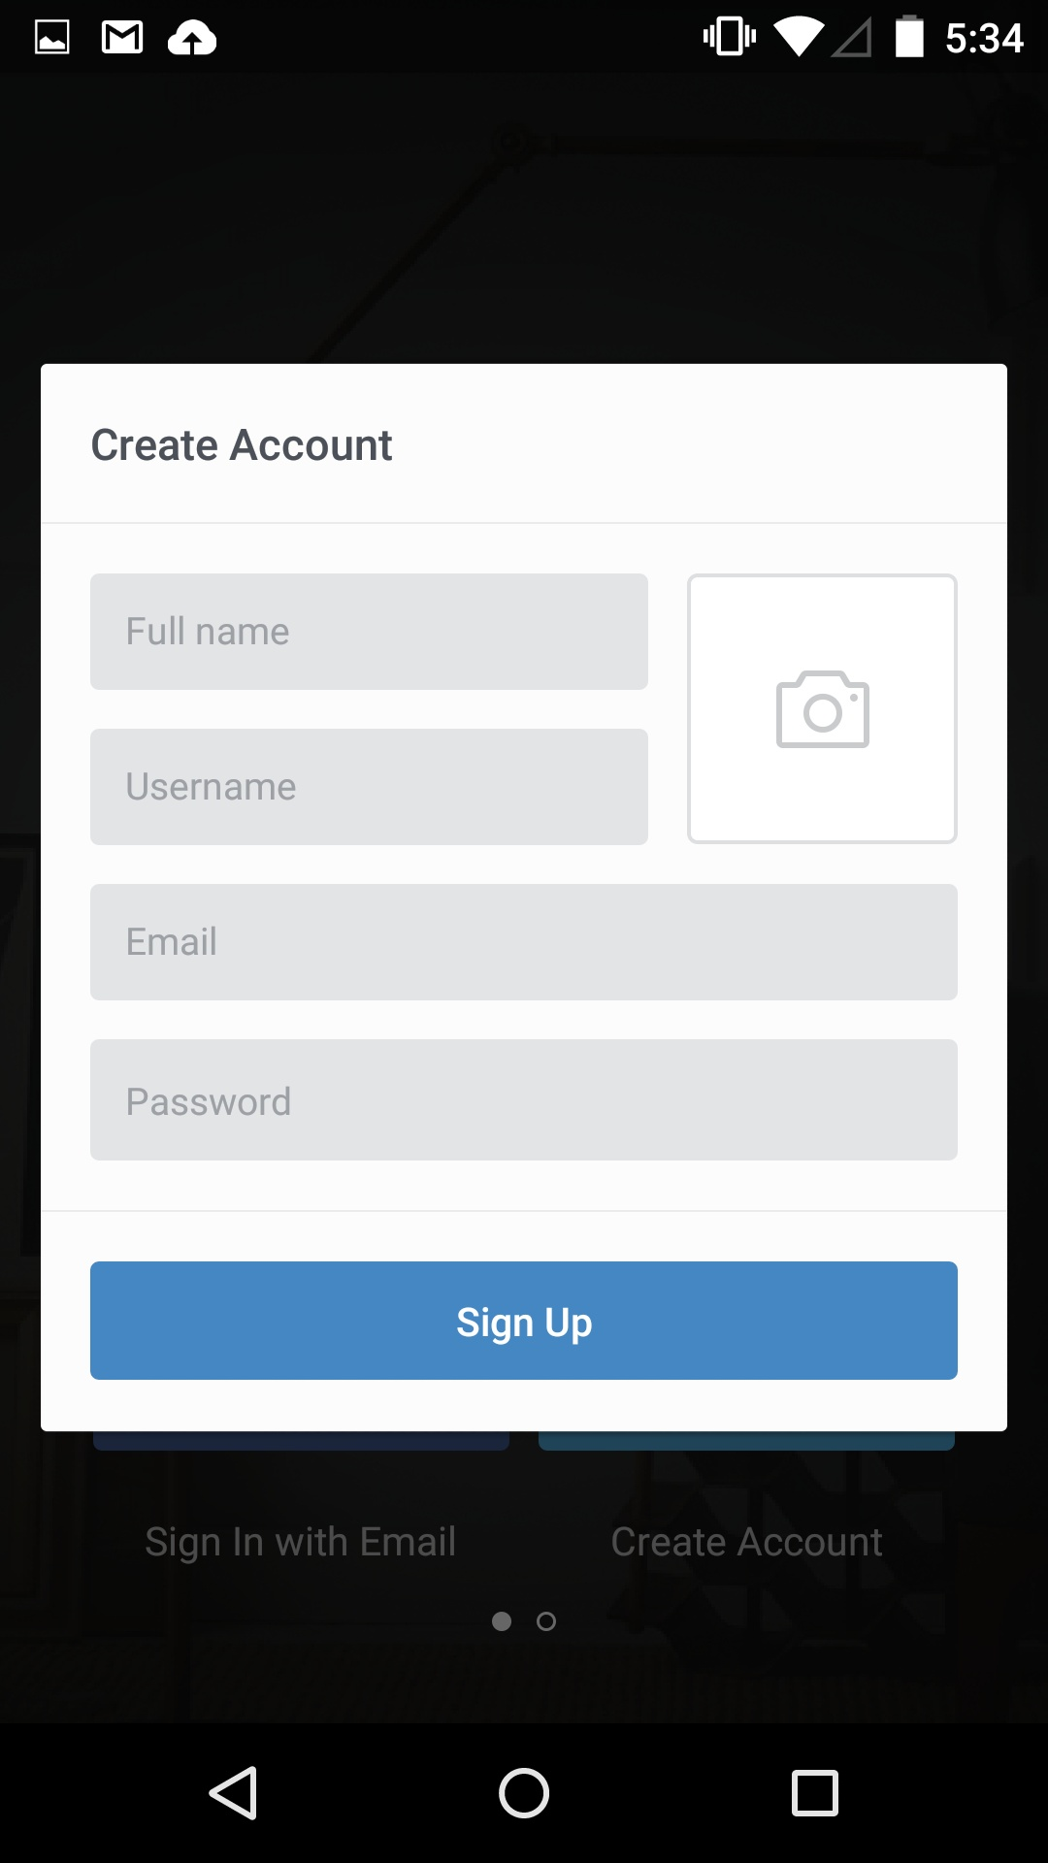

This is a reference UI.

More inspiration can be found on <http://pttrns.com/patterns?scid=9>